**EX-3:**

**APPLY HR ANALYTICS TO MAKE A PREDICTION OF THE DEMAND FOR HOURLY EMPLOYEES FOR THE FOLLOWING MONTH OR FOR THE NEXT FEW YEARS USING R PROGRAMMING**

**PROGRAM:**

Step-by-step Forecasting in R

**Step 1: Install packages (only once)**

install.packages("forecast")

install.packages("ggplot2")

install.packages("readr")

**Step 2: Load packages**

library(forecast)

library(ggplot2)

library(readr)

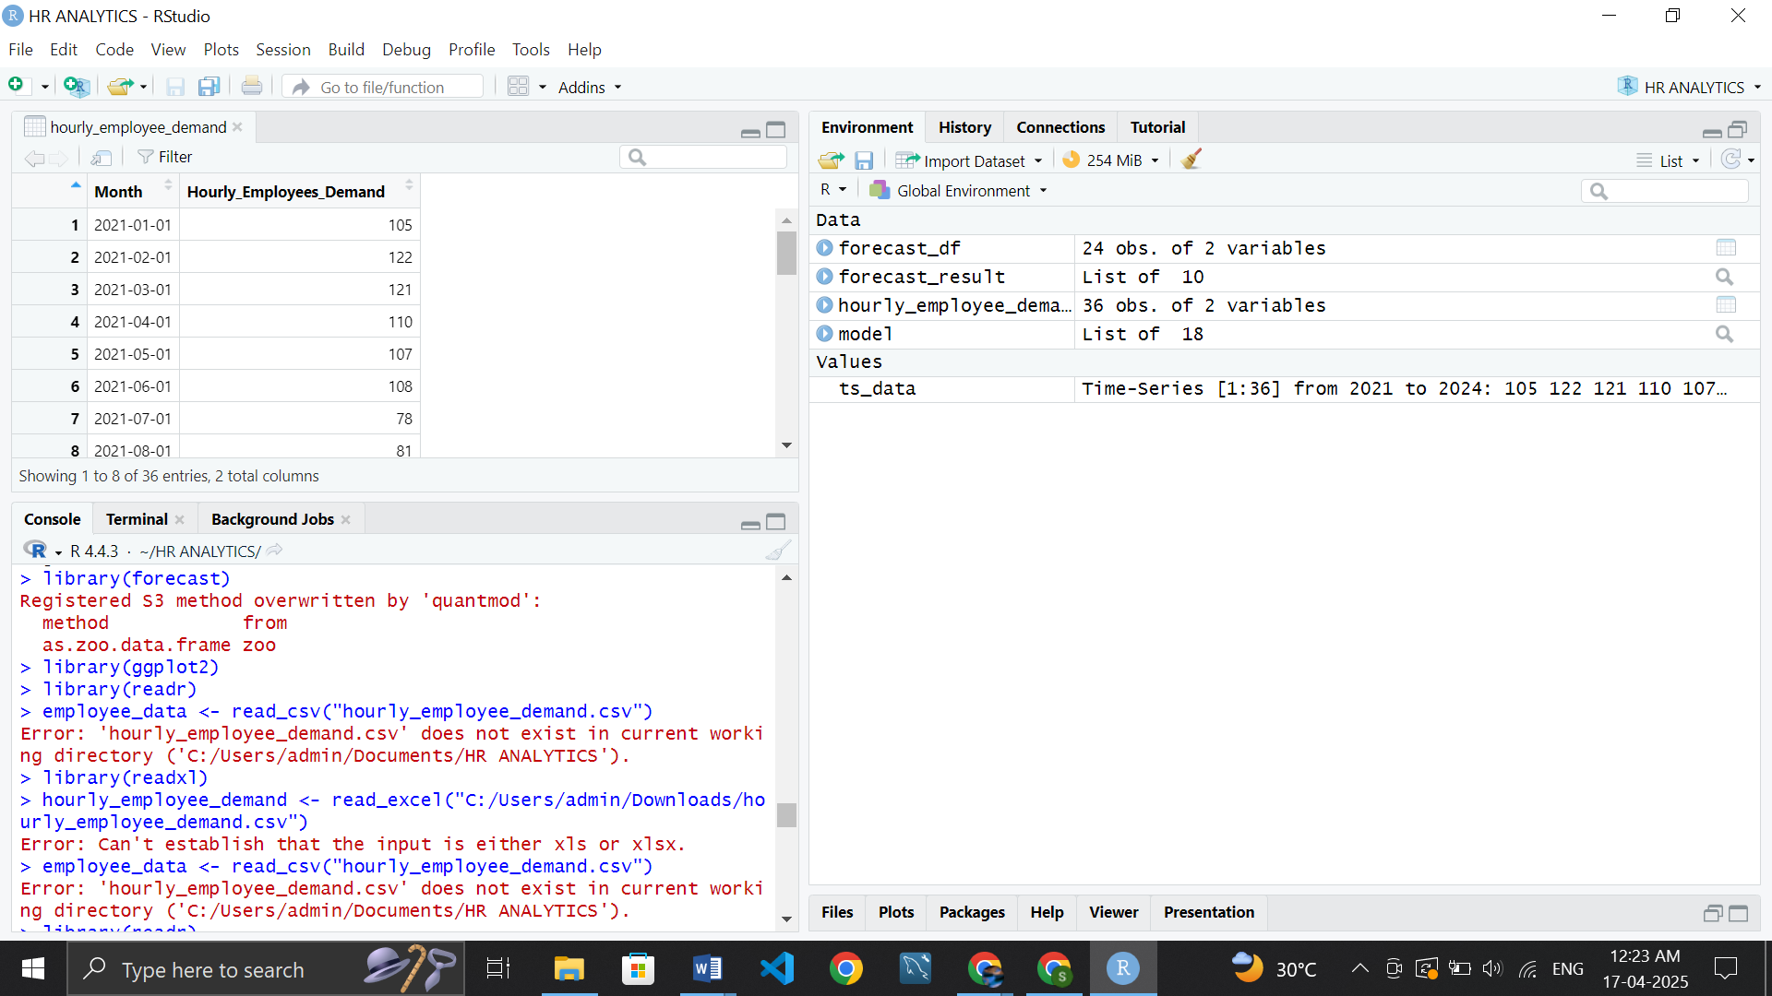

**Step 3: Load the data**

employee_data <- read_csv("hourly_employee_demand.csv")

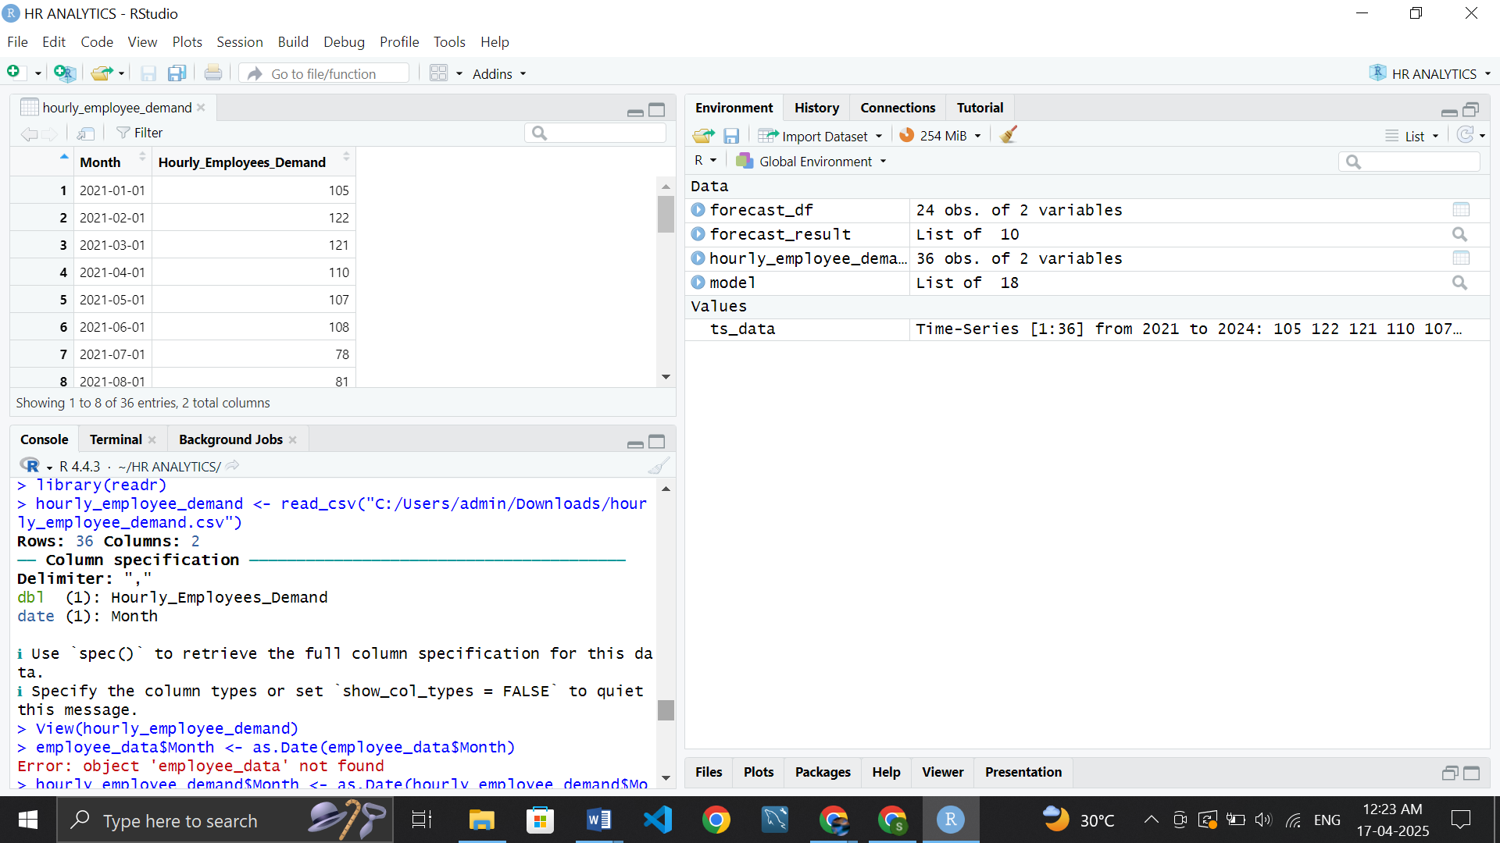

**Step 4: Convert Month to Date**

employee_data$Month <- as.Date(employee_data$Month)

**Step 5: Create a time series object (monthly data from Jan 2021)**

ts_data <- ts(employee_data$Hourly_Employees_Demand,

start = c(2021, 1), frequency = 12)

**Step 6: Plot the original data**

plot(ts_data, main = "Historical Demand for Hourly Employees", col = "blue")

**Step 7: Build ARIMA model**

model <- auto.arima(ts_data)

summary(model)

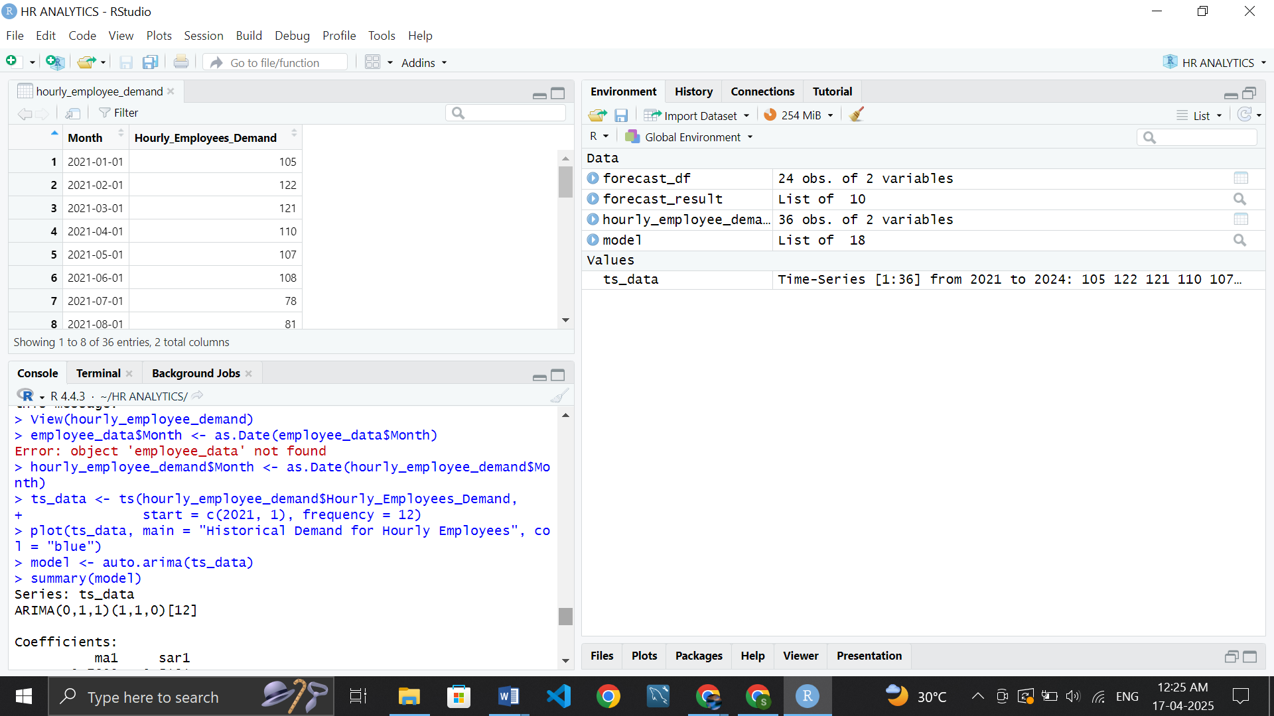

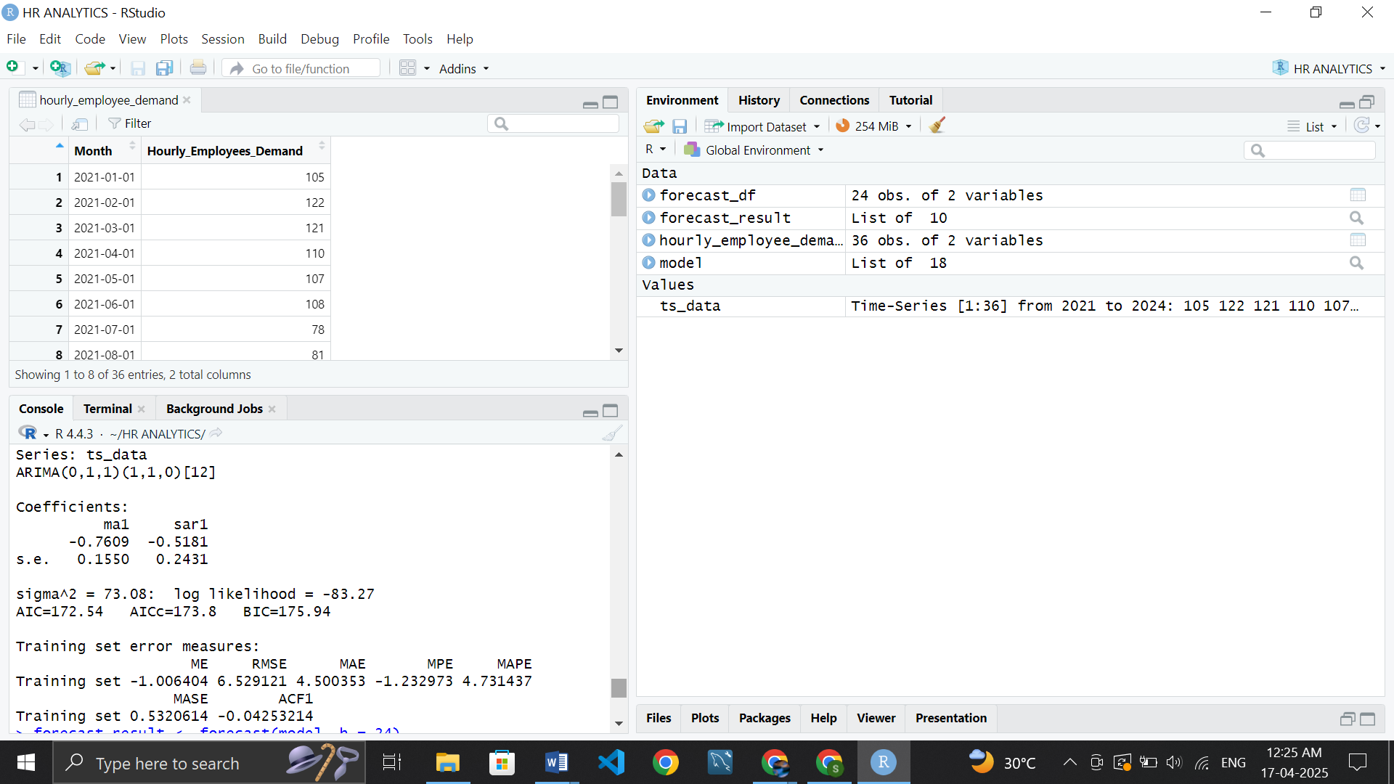

**Step 8: Forecast next 24 months**

forecast_result <- forecast(model, h = 24)

**Step 9: Plot the forecast**

plot(forecast_result, main = "Forecast of Hourly Employee Demand")

**Step 10: Export forecast to CSV**

forecast_df <- data.frame(

Month = seq(as.Date("2024-01-01"), by = "month", length.out = 24),

Forecasted_Demand = round(forecast_result$mean)

)

write.csv(forecast_df, "forecasted_hourly_employee_demand.csv", row.names = FALSE)

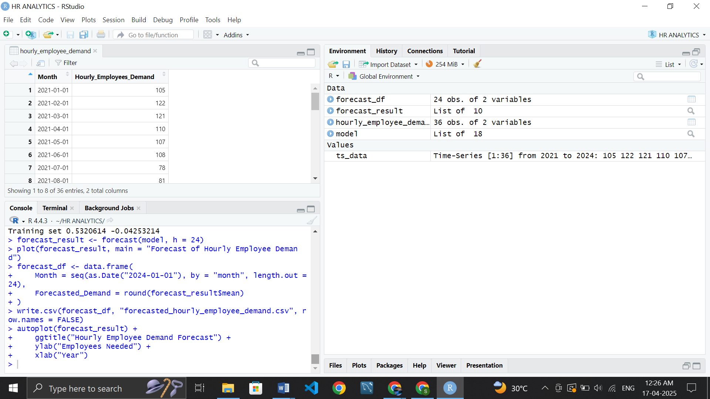

**Step 11: Optional - prettier plot**

autoplot(forecast_result) +

ggtitle("Hourly Employee Demand Forecast") +

ylab("Employees Needed") +

xlab("Year")

